**P5 Guidance**

Explain through a diagram and further explanation the stages of the systems life cycle applied to software development and show how you have followed this cycle in the previous tasks.

* You should draw the diagram on the design life cycle
* You should explain how what you have done in building the wages calculator fits in with the design life cycle
* You should explain what principles of design you have used (such as doing a proper design first, using good coding standards (as discussed in M1 and D1)
* You should explain what software structures you have used (functions, sub procedures, sequence, selection and iteration).

**System life cycle**

Gather Information

Follow the requirements set

Write program

Create/design

Test program

Maintain program

The diagram above is the steps that I followed to create a program. I set an assignment, which had a brief of M2. I followed the steps. I gathered information by looking at various types of visual studio tutorials on how to start the program off. I started it off and gradually progressed. This made my program and I tested the program, but there were some mistakes, which I fixed up.

The highlighted text below relates to the given specification, because it tells us what to do. For example, M2 gives us a criterion and if the criteria have been filled, M2 not achieved. It gives us a brief guideline of what to do. Without the specification, I would not know how to complete/start this task. Here is an example of a specification and it gives us a detailed explanation of what to do. “**Investigate the types of variables commonly used in Visual Basic programs and choose suitable variable names and data types for the values you wish to refer to in your program. Explain why you consider the chosen data types to be appropriate. (M2) Write the program, remembering to annotate your code with suitable comments showing how input, processing and output is handled here. Explain how your program satisfies the requirements of task 1**.”

.

“Public Class Form1

Private Sub Button1_Click(sender As Object, e As EventArgs) Handles Button1.Click

TextBox3.Text = Val(TextBox2.Text) * Val(TextBox1.Text)

TextBox4.Text = Val(TextBox3.Text) * Val(0.2)

TextBox5.Text = Val(TextBox3.Text) * Val(0.1)

TextBox6.Text = Val(TextBox3.Text) - Val(TextBox4.Text) - Val(TextBox5.Text)

End Sub

Private Sub Button2_Click(sender As Object, e As EventArgs) Handles Button2.Click

Close()

End Sub

Private Sub Button3_Click(sender As Object, e As EventArgs) Handles Button3.Click

Form2.Show()

Form2.TextBox1.Text = Me.TextBox1.Text

Form2.TextBox2.Text = Me.TextBox2.Text

Form2.TextBox3.Text = Me.TextBox3.Text

Form2.TextBox4.Text = Me.TextBox4.Text

Form2.TextBox5.Text = Me.TextBox5.Text

Form2.TextBox6.Text = Me.TextBox6.Text

Public Class Form2

Private Sub Button1_Click(sender As Object, e As EventArgs) Handles Button1.Click

PrintForm1.Print()

End Sub

End Class”

This is the codes that I have used in my programme is below. As I have stated before, if I have not used this code it would not work. The green highlighted box is the first code for the calculations. Therefore, I inserted these based on the flowchart that I have made previously to give me an outline of what to do. The green highlighted box gives instruction to close the program once it has been finished. The black highlighted box is the codes for the transferring all the data from form 1 to form 2. Lastly, the orange highlighted box is the print code. I found the code on the internet, which made me print my form in order to finish it off.

First, you have to have the program, MS Visual Studio 2012 for you to make a program. If you do not have this software, you will not be able to make a program.

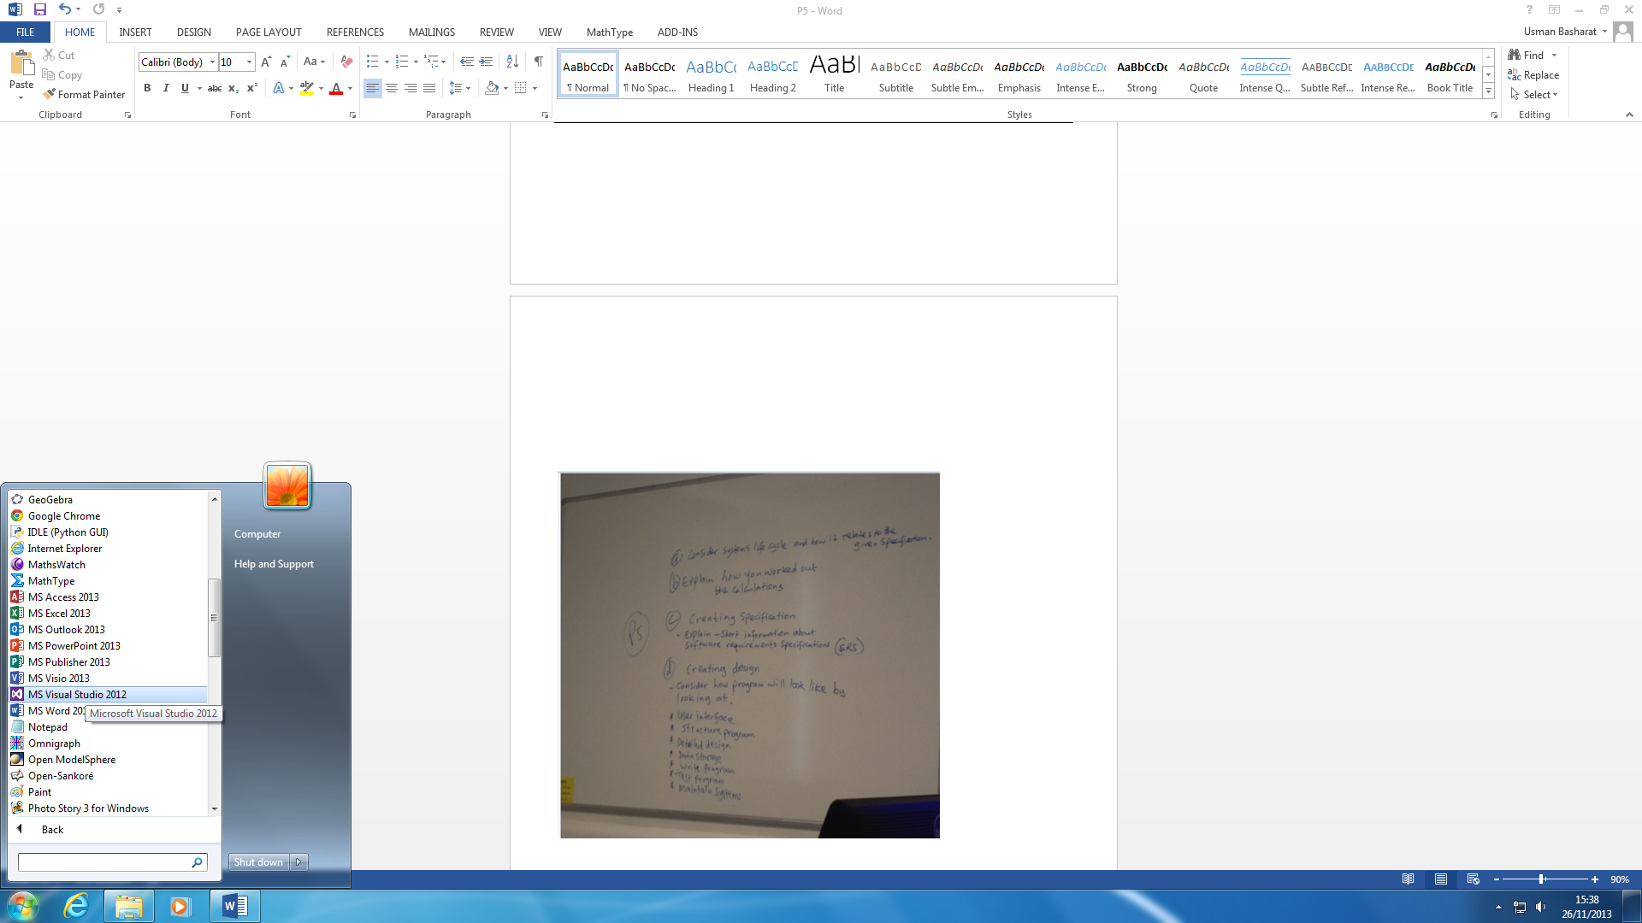Once you have browsed this software, they will need the setting. You will need to choose ‘General Development Settings’. This includes all the settings being default. Therefore, once you open this software again, it will have this settings again.

**How I made the programme**

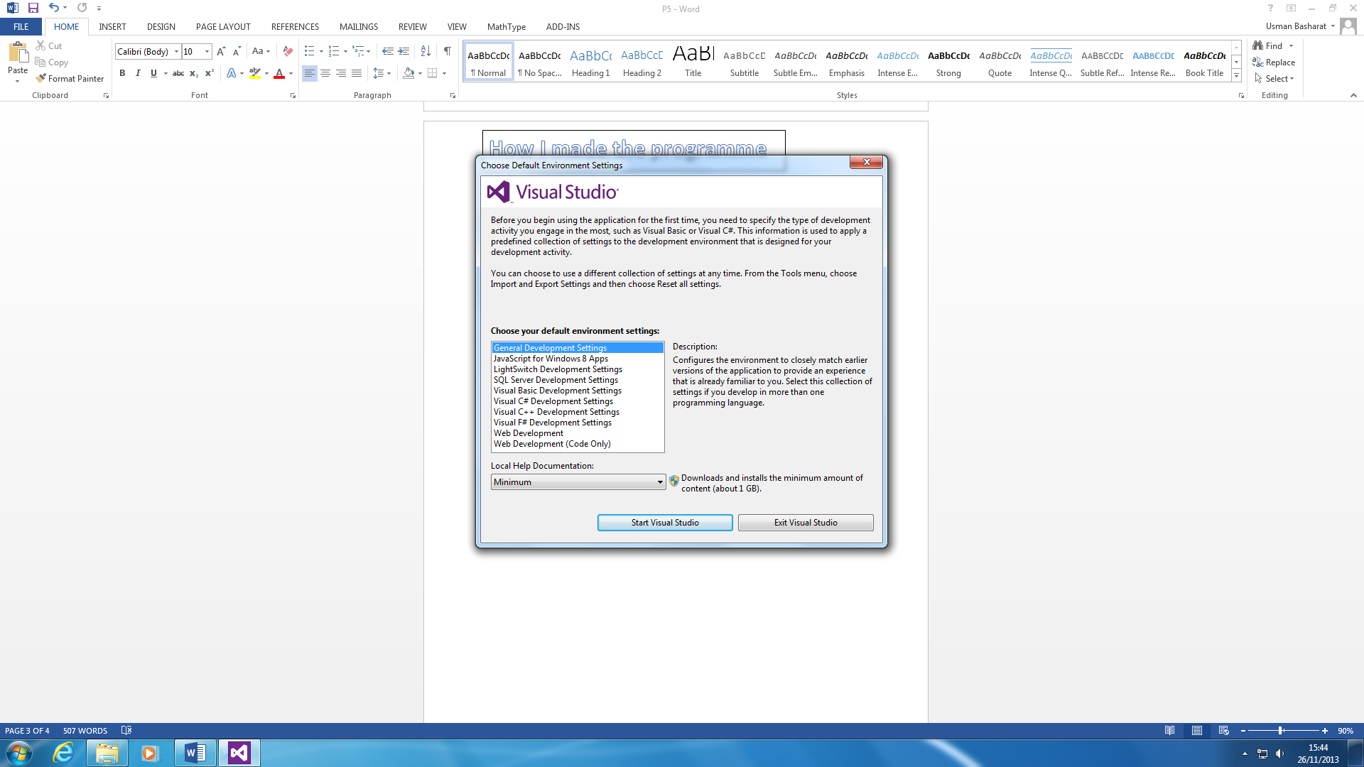

You can either open the project, but since I have created one myself. I am going to open my own.

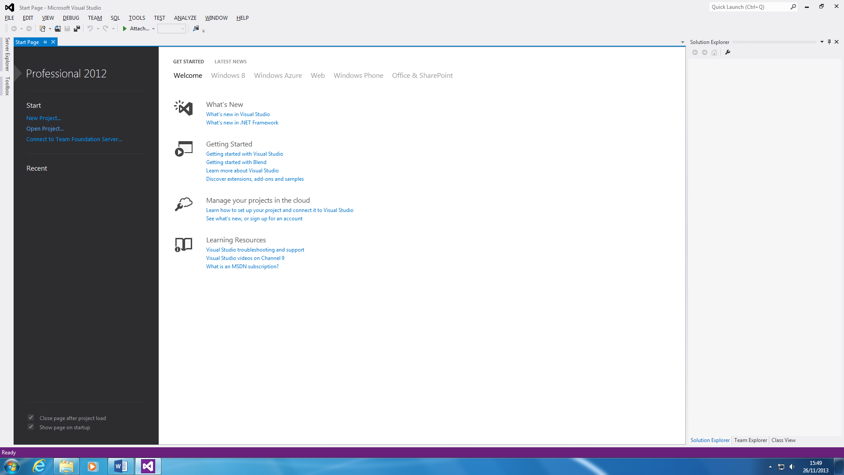

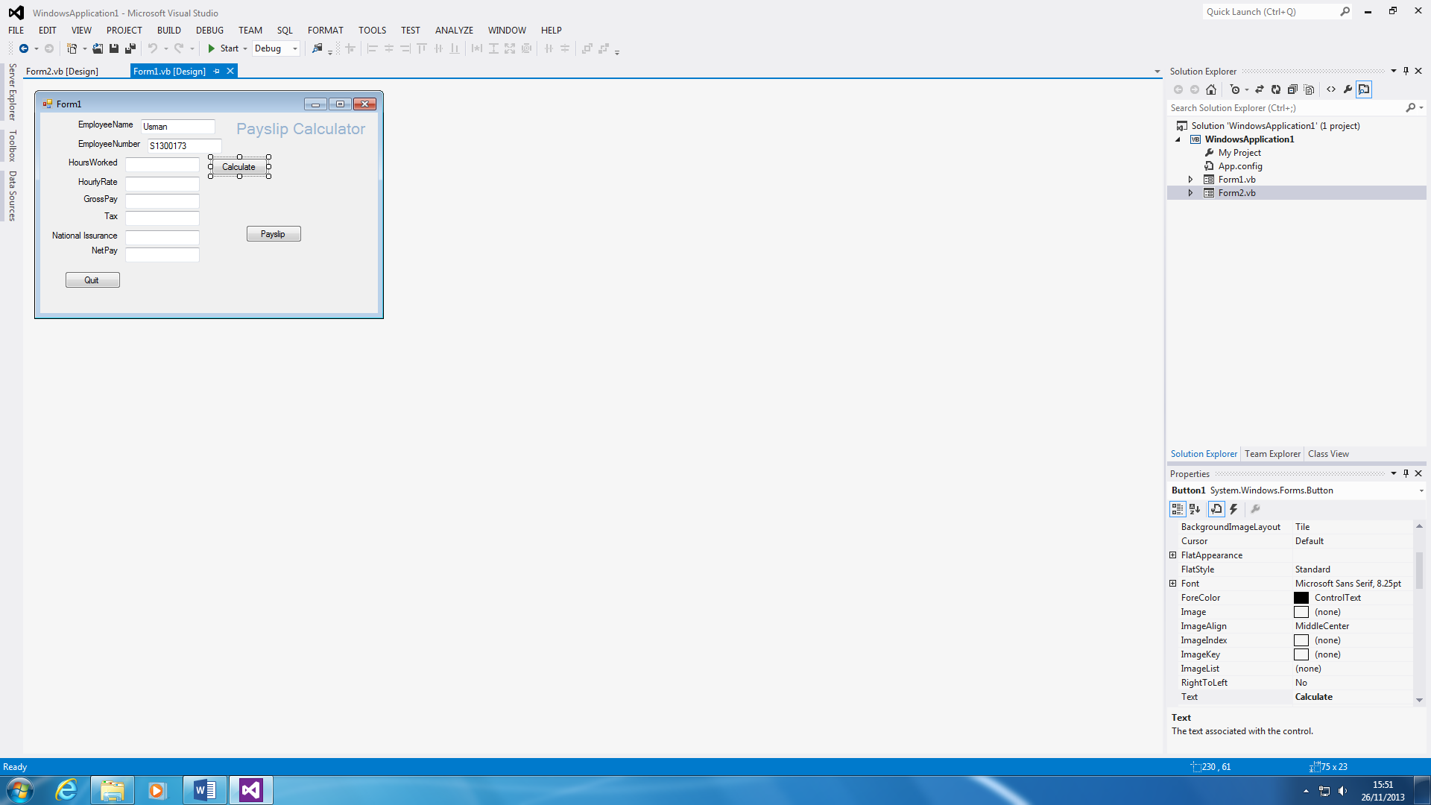You will need to use the toolbox to create these boxes and buttons. Once you have created it. You need to double click the button to enter all the codes. The codes are the most important part because if you do not know the codes, you will not give instructions to the programme to begin.

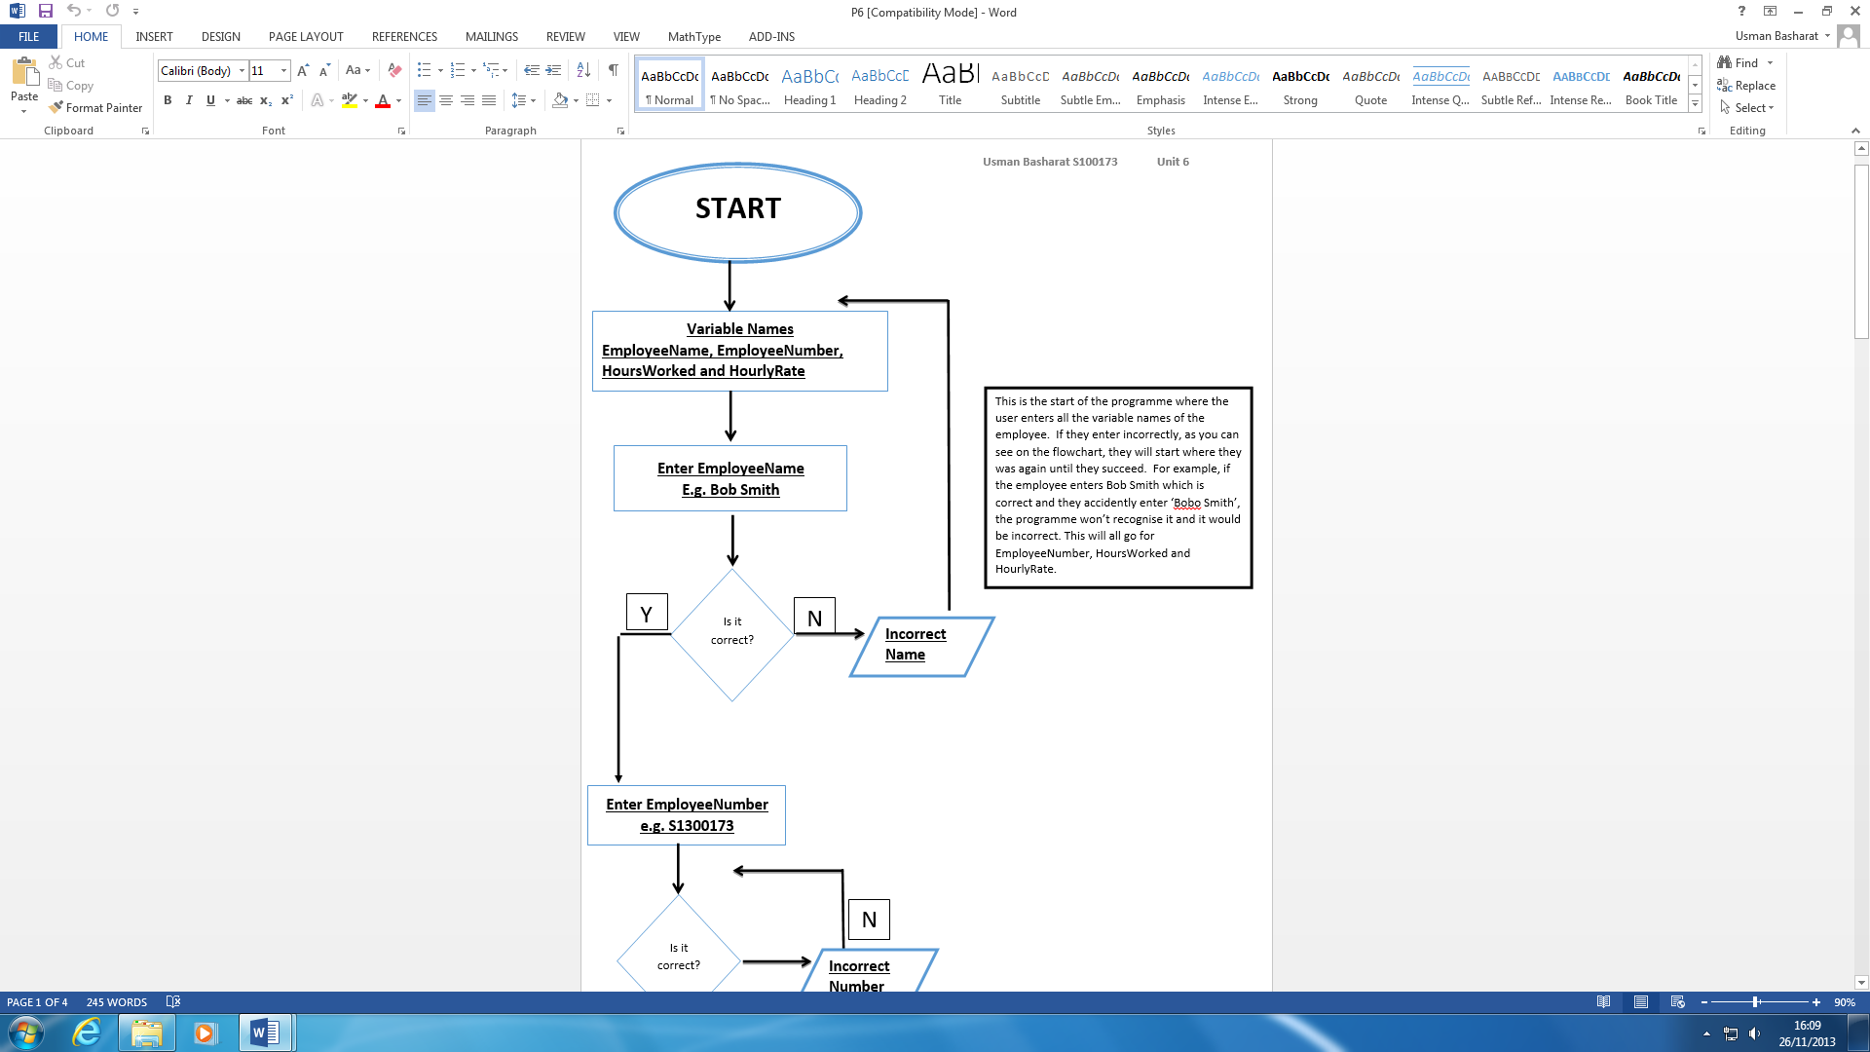

I have made a flowchart, which gave me a guideline of how to create the programme. Therefore, I had a specification to create this programme. The starter variables that I included in my flowchart, it is in my programme as well.

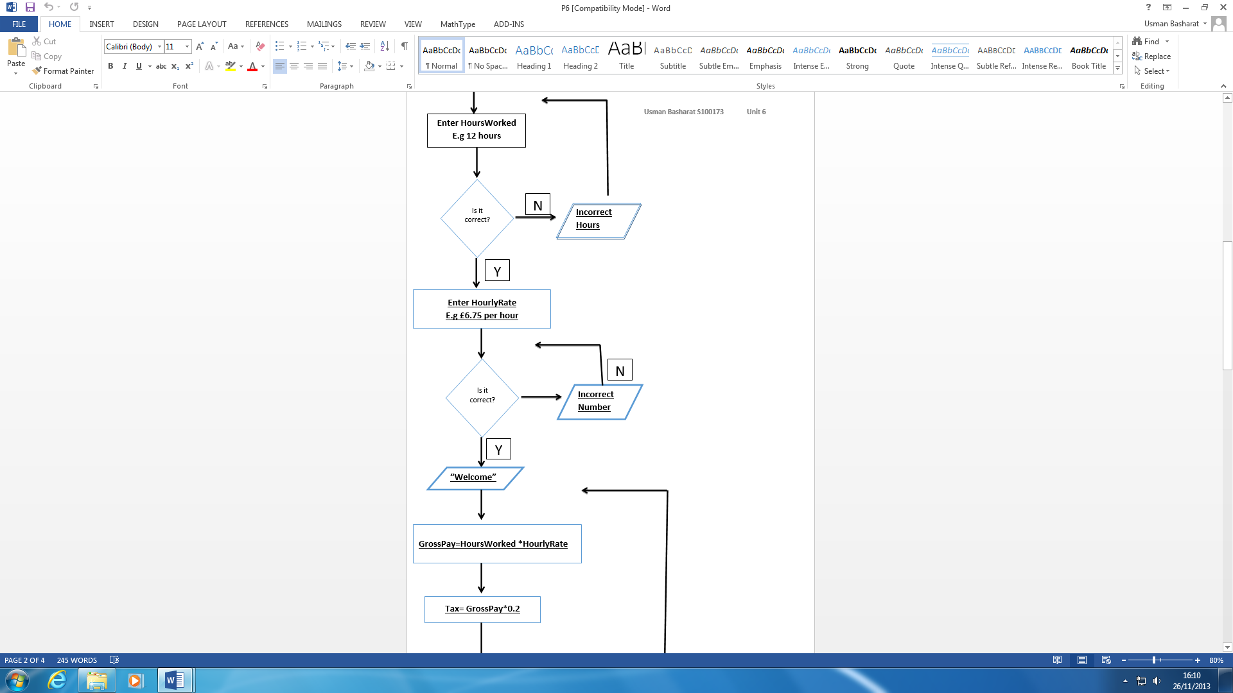

I came up with the codes because I used my flowchart as this gave me a guideline of how to create it. For example, GrossPay = HoursWorked * HourlyRate. This was inserted but in a different way.

**Test Program**

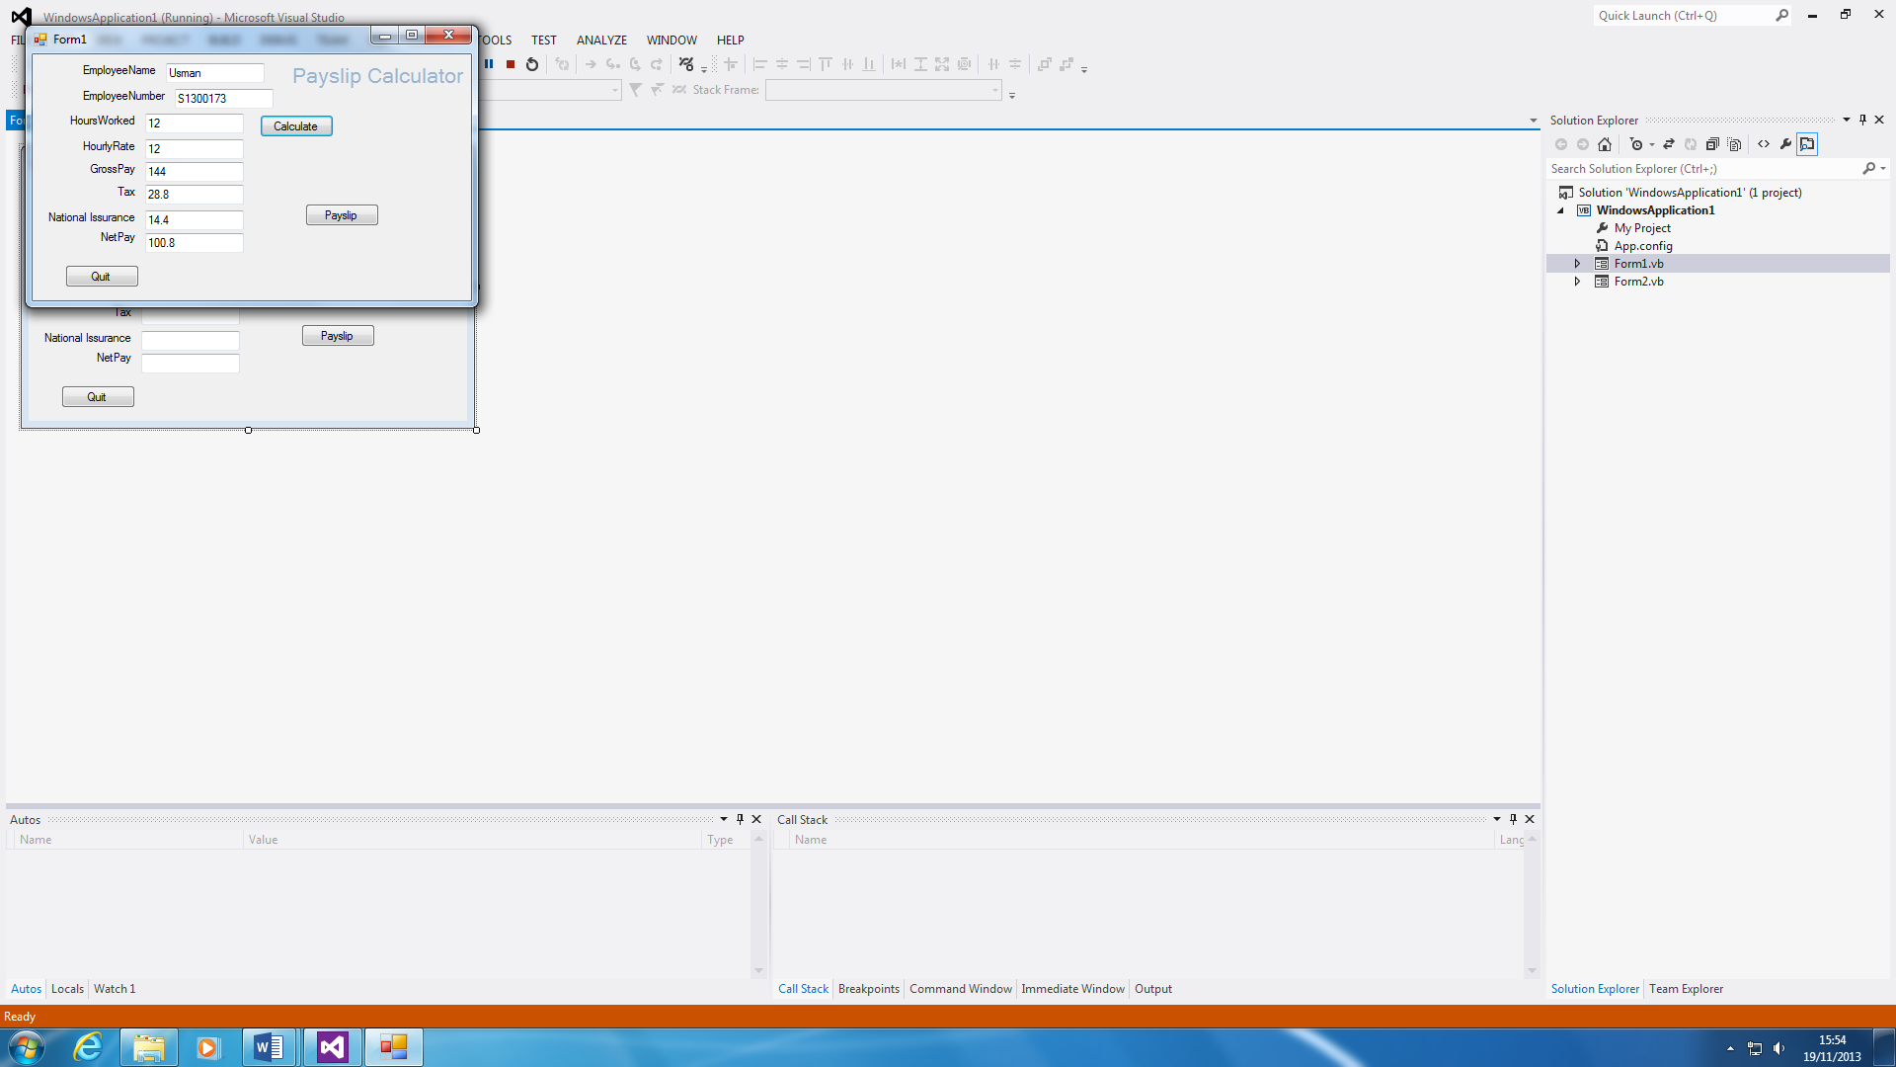To test the program, I will always press the “start” button on visual studio. This will bring up the entire program together as shown on the picture to the right. If you insert the amount of hours you worked and the hourly rate, the calculation will be done for you once you press the ‘calculate’ button. If there were any errors once pressing the start button, it would be detected automatically. For example, the GrossPay adds the HourlyRate and HoursWorked. You will need to fix that as it shows by changing the code from ‘plus’ to ‘times’.

“**TextBox3.Text = Val (TextBox2.Text) * Val (TextBox1.Text)”**

**Monitoring the program**

It is always important that you monitor the program. This is to ensure that the program is not misbehaving. In addition, if you update the program, they might come across new features that can interrupt the current features that have attached to the program. If they keep up monitoring the program, the program would not have to deal with any errors and issues. Sometimes, without notice, the program or codes could delete. Even if there is an update on the program, the program could be upgraded with new features. Therefore, the programmer needs to check that no codes are missing and that everything is working perfectly. The advantage is that if you monitor the program, it detects any mistakes and errors.